To,

The HR Date: 18/07/2015
HDFC BANK Ltd.

Dear Sir/ Mam,

I am Himanshu Dutt Mishra, showing the interest to work with your prestigious and esteemed organization, because I want to see my brighter future with your fastest growing organization. My dedication and passion about my work is waiting for getting the best opportunity with your prestigious and esteemed organization.
I am waiting to get positive response from your side and hoping to be a strong part with the organization.

Thank you.

Regards,

Himanshu Dutt Mishra
8533095523, 7895374612
arnold.pintoo@gmail.com
H.No.- 43, Dhruv Nagar, Bank Colony
Bodla-Paschimpuri Road, Agra- 282007
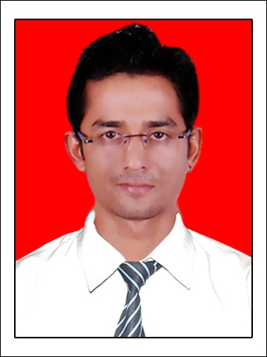
Himanshu Dutt Mishra
H. No. – 43, Dhruv Nagar,Bank Colony
Bodla-Paschimpuri Road,Sikandra
Agra- 282007
(Uttar Pradesh)
Email ID: arnold.pintoo@gmail.com
Cell No.: 8533095523, 7895374612

Objective:

To take up a challenging career in a prestigious and esteemed organization where my skills and abilities can be utilized and to grow along with the organization.

Educational Qualifications:

Course | Institute | University | Year | % Marks /  CGPA
M.B.A. | IBS, Ranchi | ICFAI University, Jharkhand | 2010-2012 | 6.76 CGPA
B.Pharma. | Anand College Of Pharmacy, Keetham, Agra(U.P.) | Uttar Pradesh Technical University,Lucknow (U.P.) | 2006-2010 | 64.11%
B.Sc.-Hons (Chemistry) | Dayalbagh Educational Institute,Agra(U.P.) | Dayalbagh Educational Institute,Deemed University, Agra (U.P.) | 2003-2006 | 55%
12th (Intermediate) | Pt. Gyasiram Sharma Inter College, Agra(U.P.) | Uttar Pradesh Board, Allahabad (U.P.) | 2003 | 58%
10th  (High School) | St. Johns Inter College, Agra(U.P.) | Uttar Pradesh Board, Allahabad (U.P.) | 2000 | 51%

AREA OF SPECIALIZATION:

Finance and Marketing

Computer Proficiency:

- Knowledge of MS-OFFICE and SPSS.

Professional Work Experience:

(1). Working as Relationship Manager in Reliance Securities Ltd From 17th December 2014 in Agra.

Work Objective:
-To open Trading accounts of clients.
-To do cross sell and upsell of all Retail Financial products.
-To provide the Portfolio to the client for investing in all Retail Products
-To build long term relationship with clients to generate big margins and brokerage for the organization.

(2). Worked as Customer Service Manager- Branch Banking in Indusind Bank From 28th April 2014 to 04th August 2014 in Kanpur.

Work Objectives:
- To provide banking services to the customers.
- To do cross sell and up sell to new and existing clients of the bank.
- To provide financial planning & portfolios to the clients.
- To resolve customer queries regarding their investments.
- To retain existing clients of the bank.

(3). Worked as Senior Officer - Customer Advisory Team in Max Life Insurance from 18th July 2012 to 30th June2013 in Agra.
Work Objectives:
- To provide financial services to new and existing clients.
- To prepare financial reports and planning of new and existing clients.
- To do cross sells- up sells to new and existing clients after providing the services.
- To make strategies to tackle out the problems during financial planning.

Certifications:
- IRDA Certified.
- AMFI Certified.

Major Projects Handled:

Summer Internship Project (MBA):

Name of Company : Reliance Retail Ltd.
Duration : 14 Weeks
Project Topic : Performance Study of Branded products Vis-à-vis Own products in Reliance Mart

- One Month Summer Training in Unichem Laboratories Ltd. in Production Department in Ghaziabad in June 2009.
- Management Research Project on “Comparative Study of Financial Report on Three Banks of India (State Bank of India, ICICI Bank, Punjab National Bank)” in Final project of M.B.A.

Achievements:
- Participated in “Aarambh-2011” in quiz (Conundrum) and debate (War of words) on 15th August, 2011 in IIM, Ranchi.
- “Paper Presentation” on “SARS” in National Level Technical Festival “Anni Mirabilis” and participated in Dance Competition in “Anni Mirabilis” in 2007.
- National Level N.S.S. camp for 240 hours in 2003.
- Worked in Pulse Polio Program as volunteer.

Personal Details:

Date of Birth : 27/07/1985
Father’s Name : Sri. Anilendra Dutt Mishra (Branch Manager- SBI)
Gender : Male
Nationality : Indian

Area of Interest:

Dancing, Singing, Cricket, Computer Games.

Acknowledgement

I, hereby, acknowledge that all the above stated facts are true to the best of my knowledge.

Place: Agra
Date: 18/07/2015 (Himanshu Dutt Mishra)

